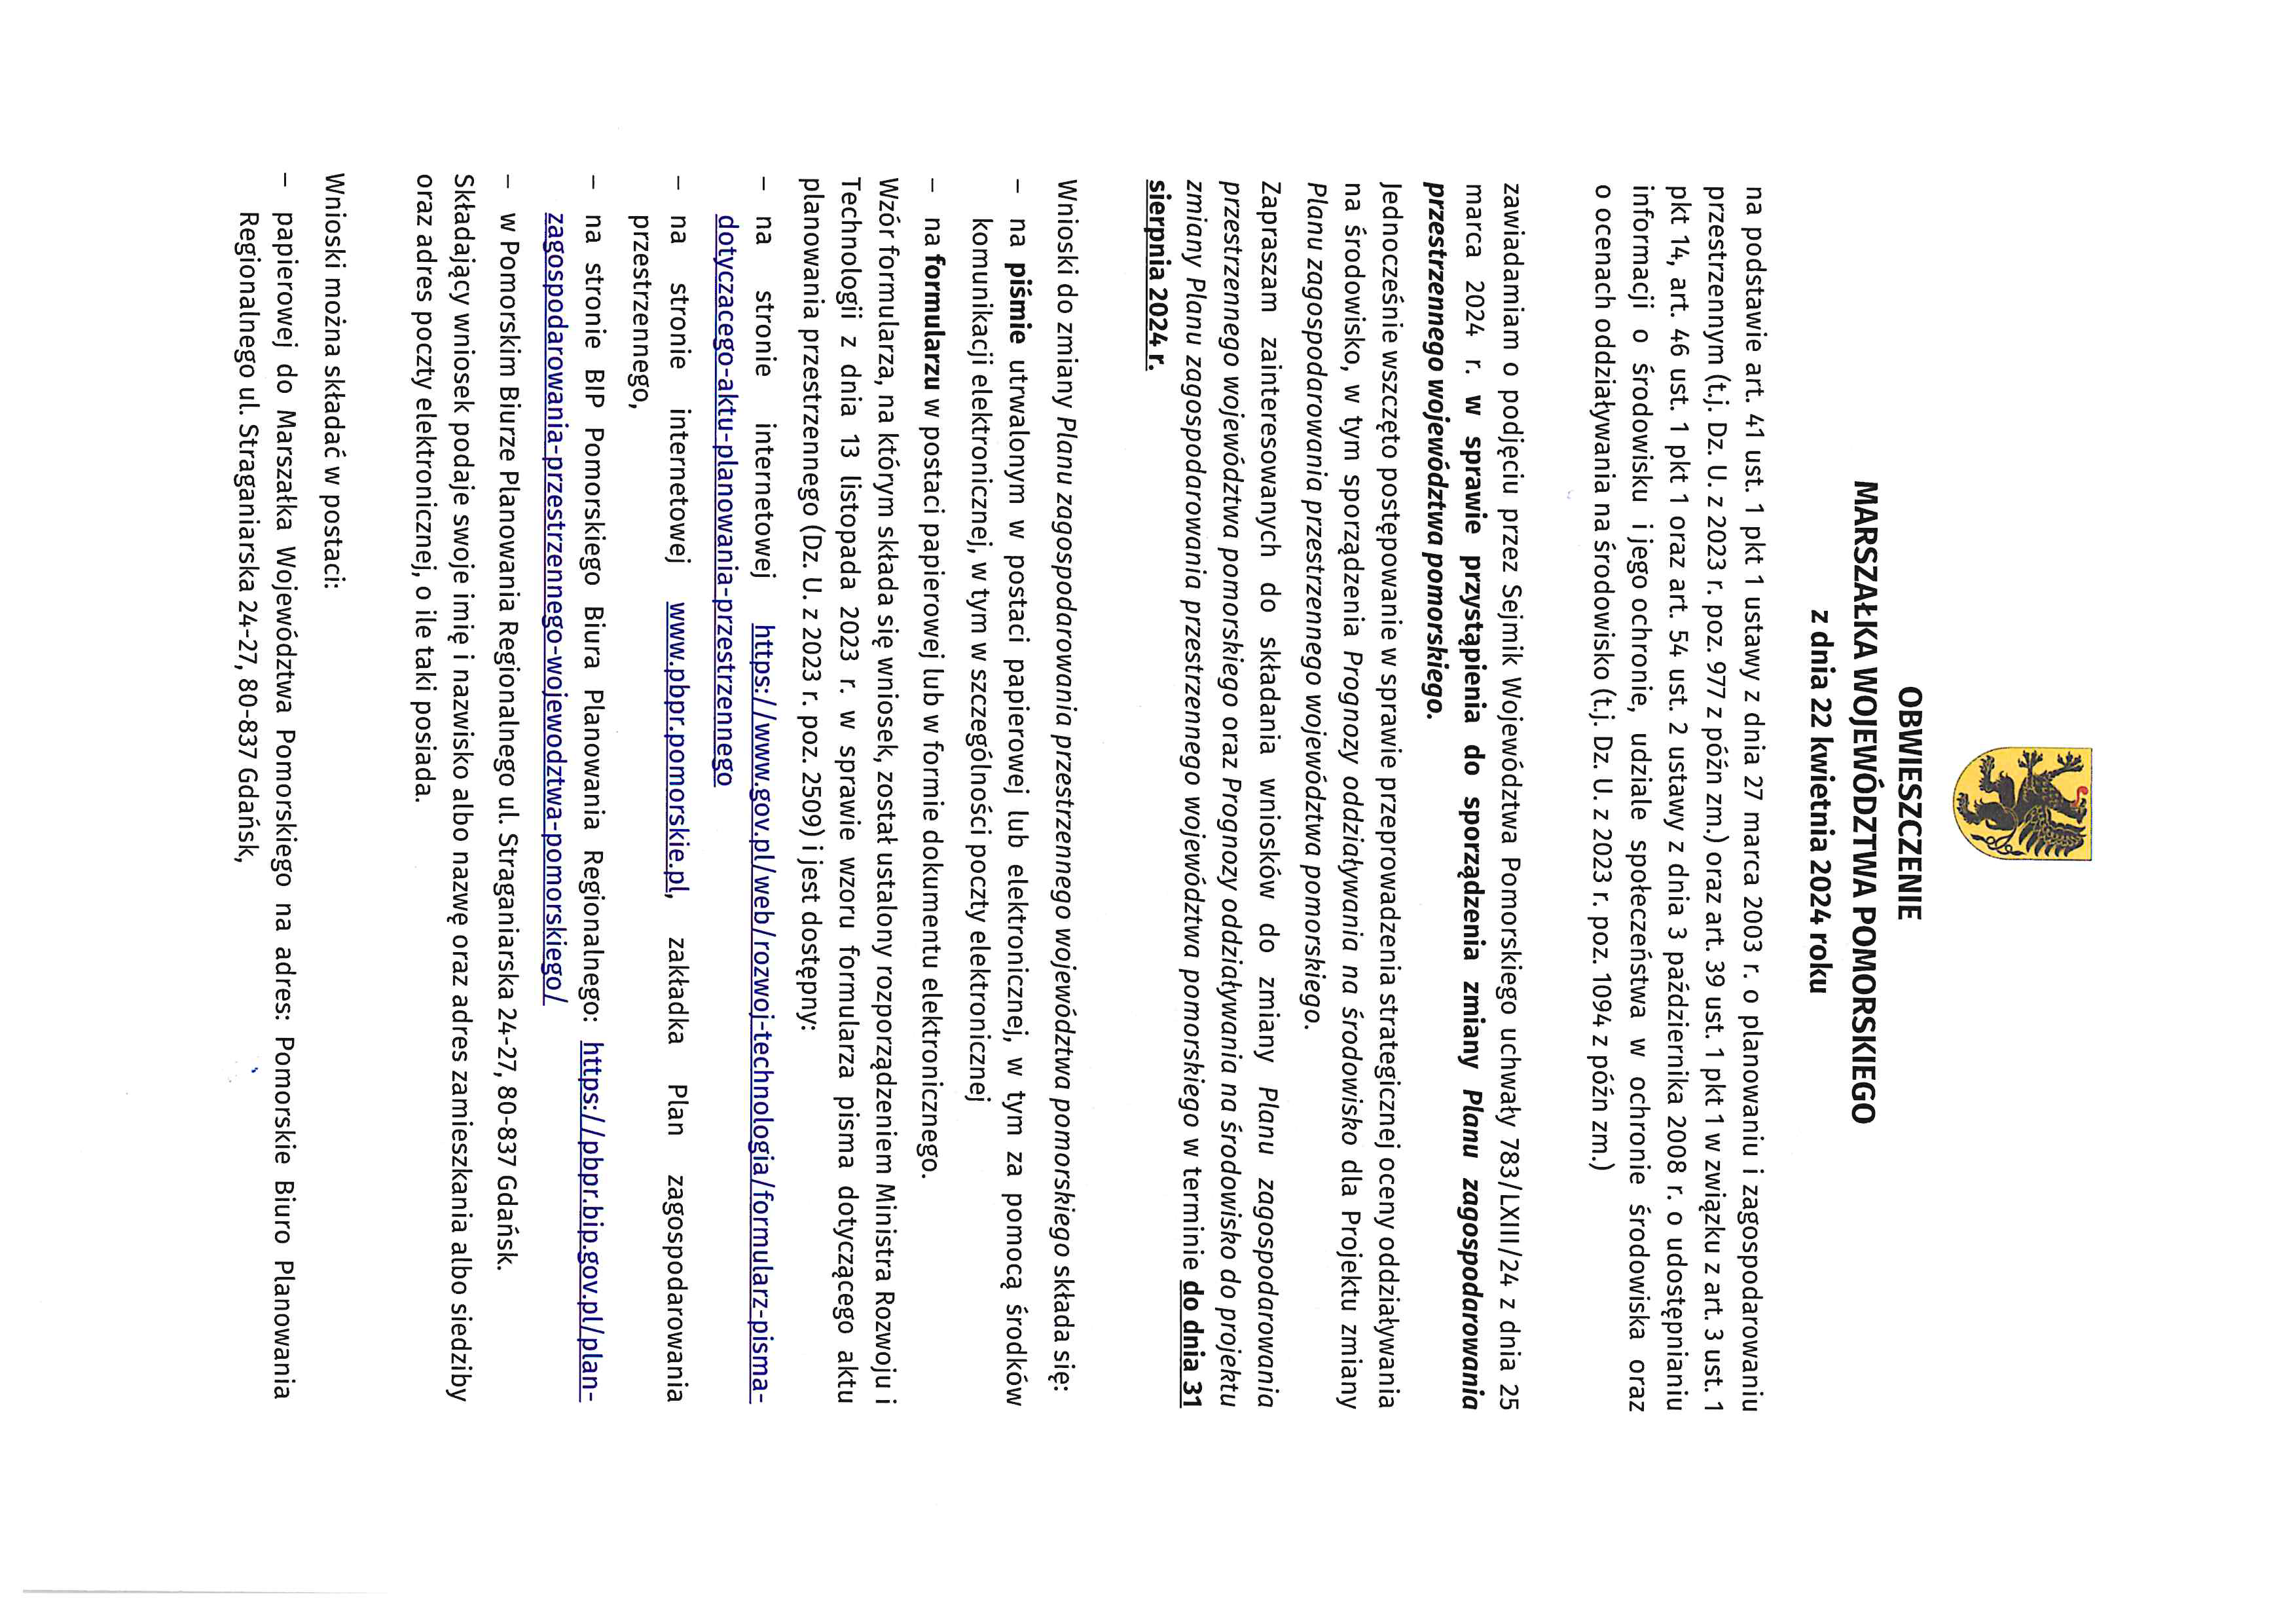
PDF-XChange Editor
DEMO
PDF-XChange Editor
DEMO
PDF-XChange Editor
DEMO
PDF-XChange Editor
DEMO
PDF-XChange Editor
DEMO
PDF-XChange Editor
DEMO
PDF-XChange Editor
DEMO
PDF-XChange Editor
DEMO
PDF-XChange Editor
DEMO
PDF-XChange Editor
DEMO
PDF-XChange Editor
DEMO
PDF-XChange Editor
DEMO
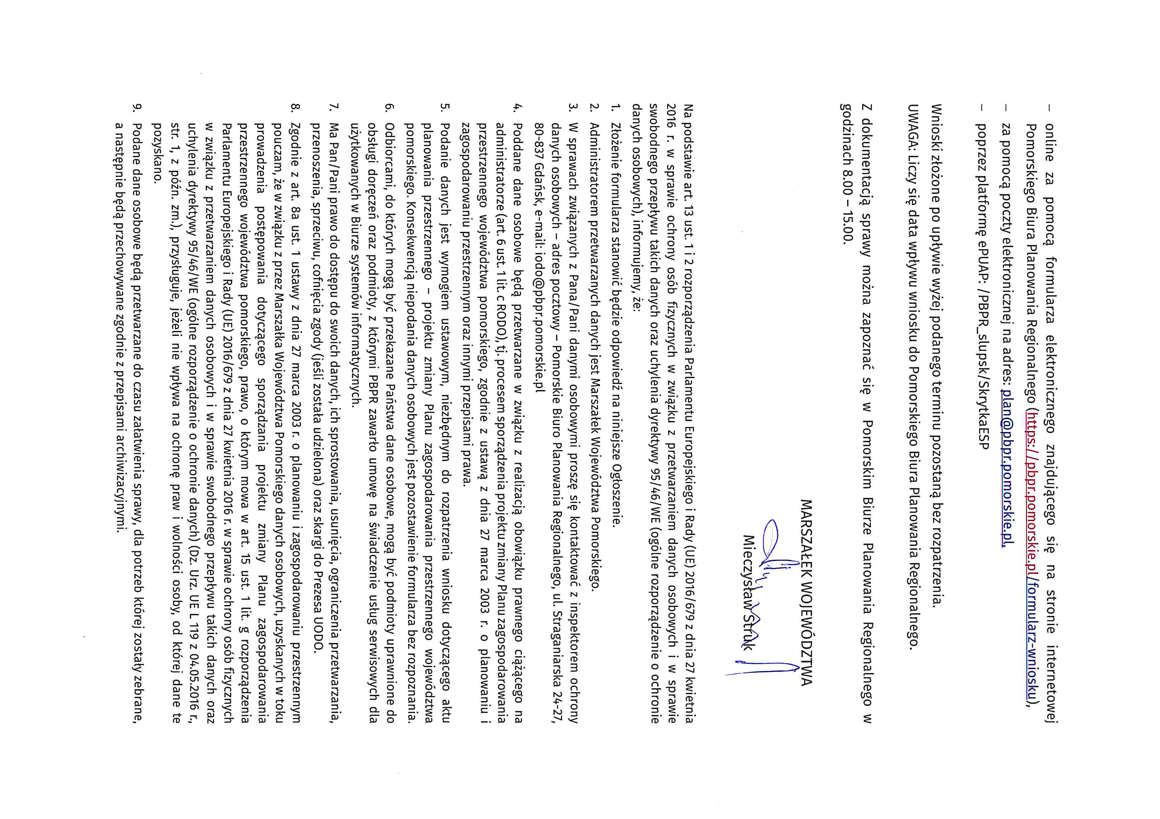
PDF-XChange Editor
DEMO
PDF-XChange Editor
DEMO
PDF-XChange Editor
DEMO
PDF-XChange Editor
DEMO
PDF-XChange Editor
DEMO
PDF-XChange Editor
DEMO
PDF-XChange Editor
DEMO
PDF-XChange Editor
DEMO
PDF-XChange Editor
DEMO
PDF-XChange Editor
DEMO
PDF-XChange Editor
DEMO
PDF-XChange Editor
DEMO

