


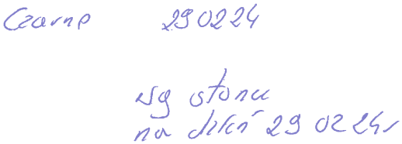



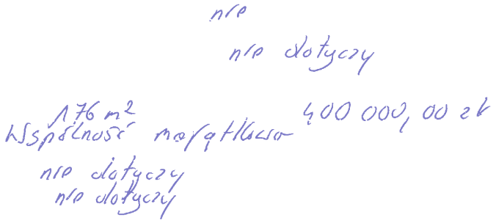
PDF-XChange Editor
DEMO
PDF-XChange Editor
DEMO
PDF-XChange Editor
DEMO
PDF-XChange Editor
DEMO
PDF-XChange Editor
DEMO
PDF-XChange Editor
DEMO
PDF-XChange Editor
DEMO
PDF-XChange Editor
DEMO
PDF-XChange Editor
DEMO
PDF-XChange Editor
DEMO
PDF-XChange Editor
DEMO
PDF-XChange Editor
DEMO

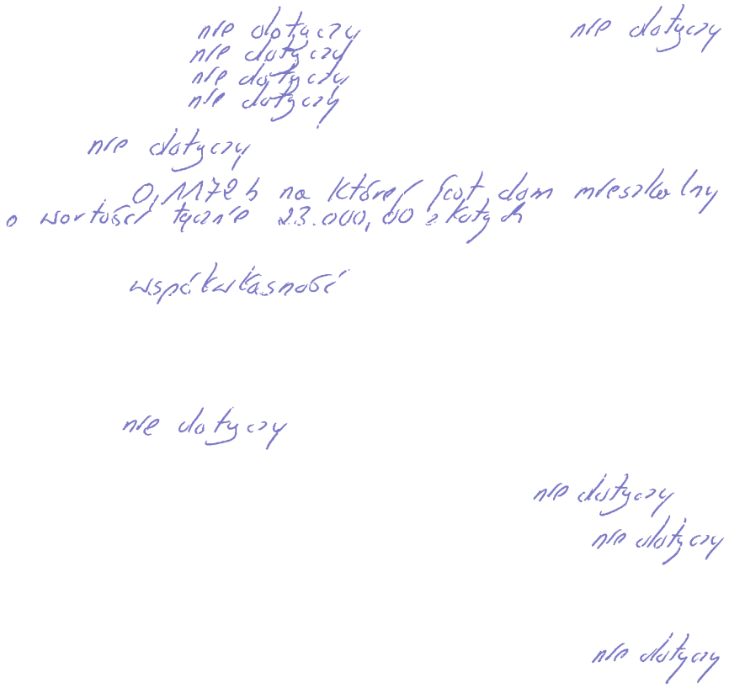
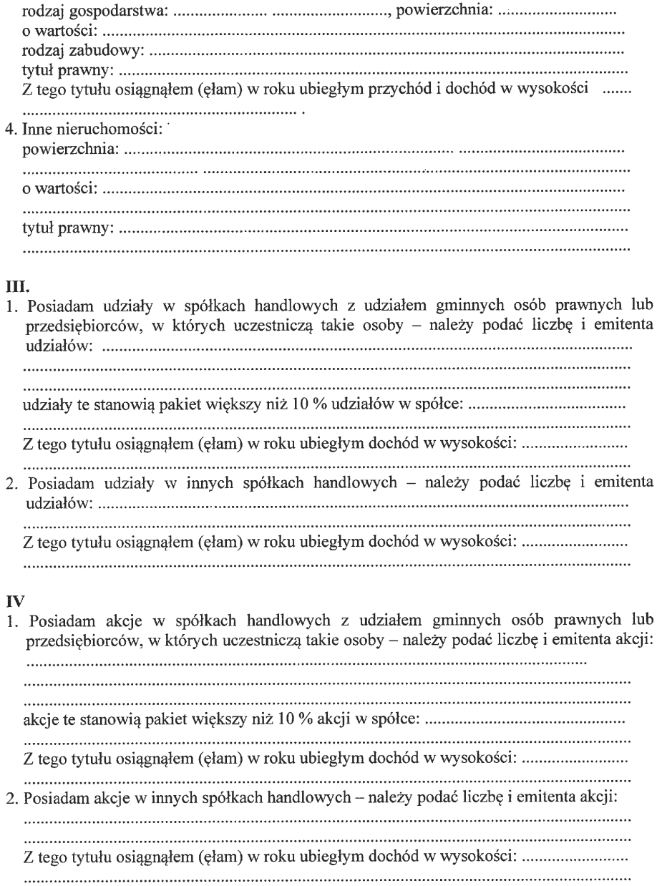


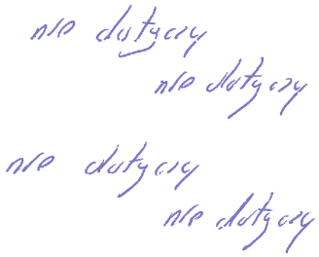
PDF-XChange Editor
DEMO
PDF-XChange Editor
DEMO
PDF-XChange Editor
DEMO
PDF-XChange Editor
DEMO
PDF-XChange Editor
DEMO
PDF-XChange Editor
DEMO
PDF-XChange Editor
DEMO
PDF-XChange Editor
DEMO
PDF-XChange Editor
DEMO
PDF-XChange Editor
DEMO
PDF-XChange Editor
DEMO
PDF-XChange Editor
DEMO

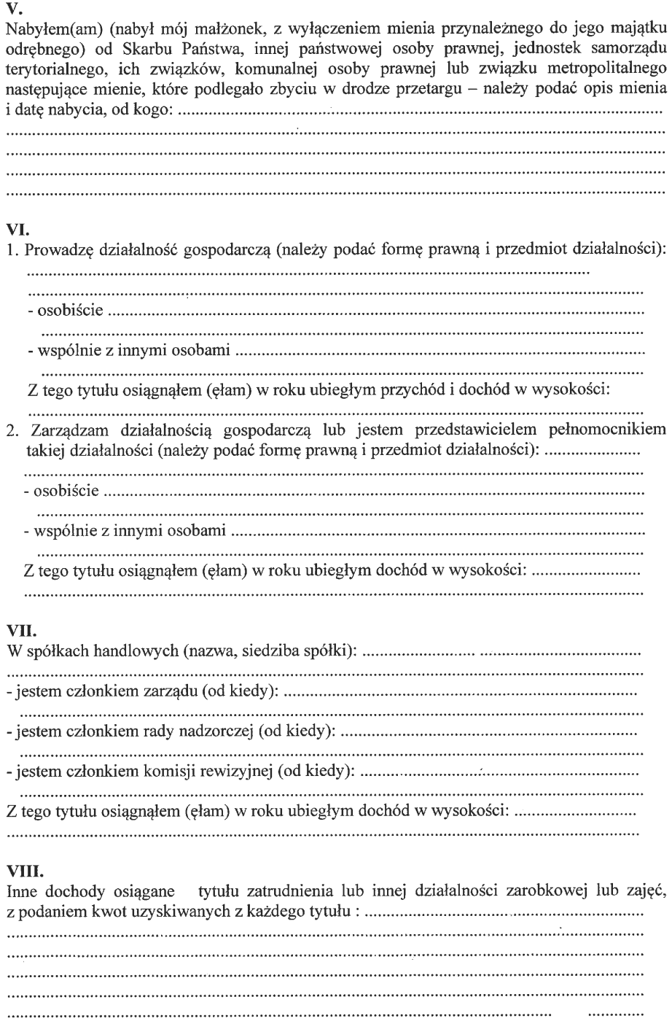
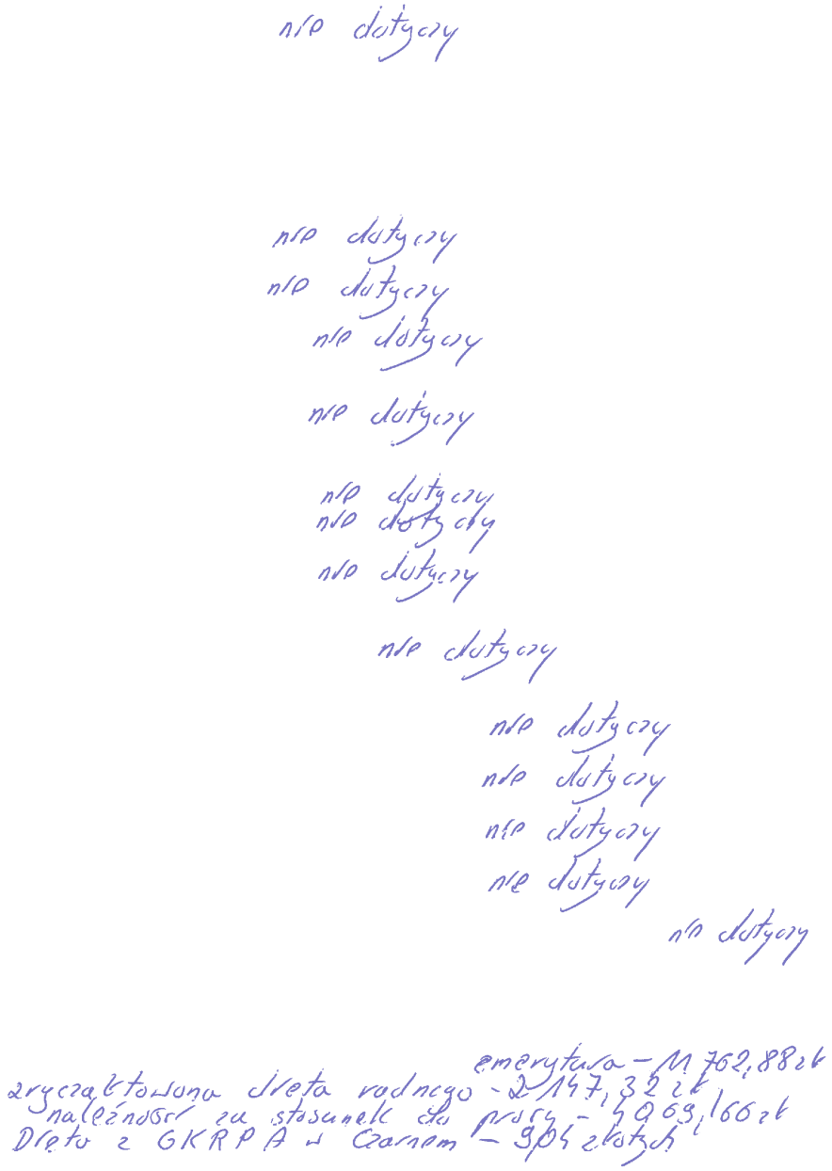
PDF-XChange Editor
DEMO
PDF-XChange Editor
DEMO
PDF-XChange Editor
DEMO
PDF-XChange Editor
DEMO
PDF-XChange Editor
DEMO
PDF-XChange Editor
DEMO
PDF-XChange Editor
DEMO
PDF-XChange Editor
DEMO
PDF-XChange Editor
DEMO
PDF-XChange Editor
DEMO
PDF-XChange Editor
DEMO
PDF-XChange Editor
DEMO

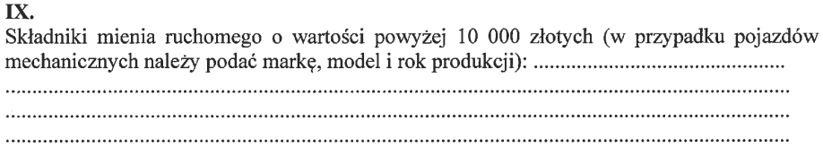



PDF-XChange Editor
DEMO
PDF-XChange Editor
DEMO
PDF-XChange Editor
DEMO
PDF-XChange Editor
DEMO
PDF-XChange Editor
DEMO
PDF-XChange Editor
DEMO
PDF-XChange Editor
DEMO
PDF-XChange Editor
DEMO
PDF-XChange Editor
DEMO
PDF-XChange Editor
DEMO
PDF-XChange Editor
DEMO
PDF-XChange Editor
DEMO




PDF-XChange Editor
DEMO
PDF-XChange Editor
DEMO
PDF-XChange Editor
DEMO
PDF-XChange Editor
DEMO
PDF-XChange Editor
DEMO
PDF-XChange Editor
DEMO
PDF-XChange Editor
DEMO
PDF-XChange Editor
DEMO
PDF-XChange Editor
DEMO
PDF-XChange Editor
DEMO
PDF-XChange Editor
DEMO
PDF-XChange Editor
DEMO

