
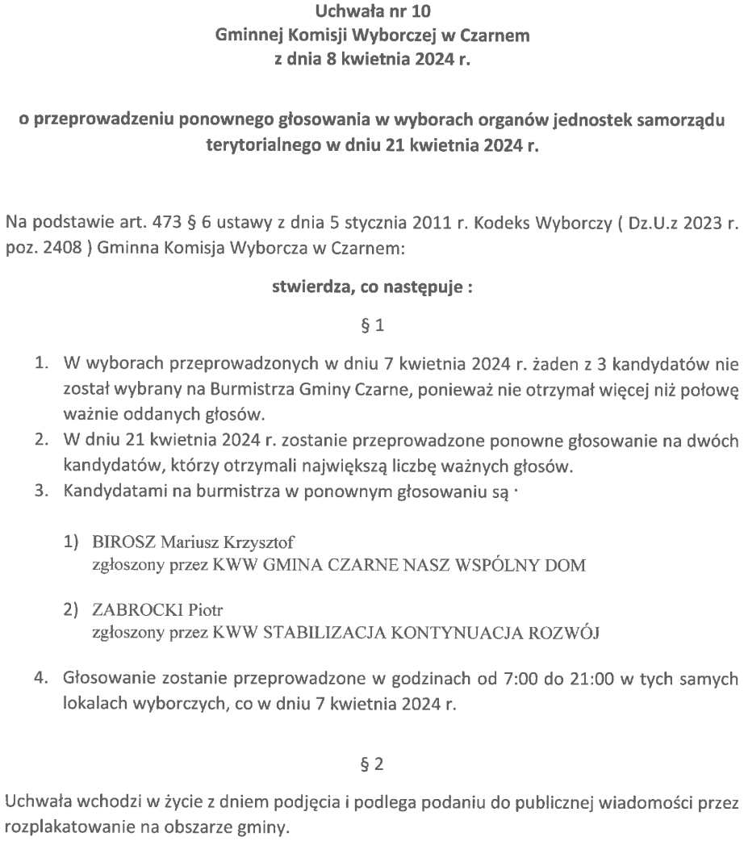



PDF-XChange Editor
DEMO
PDF-XChange Editor
DEMO
PDF-XChange Editor
DEMO
PDF-XChange Editor
DEMO
PDF-XChange Editor
DEMO
PDF-XChange Editor
DEMO
PDF-XChange Editor
DEMO
PDF-XChange Editor
DEMO
PDF-XChange Editor
DEMO
PDF-XChange Editor
DEMO
PDF-XChange Editor
DEMO
PDF-XChange Editor
DEMO

