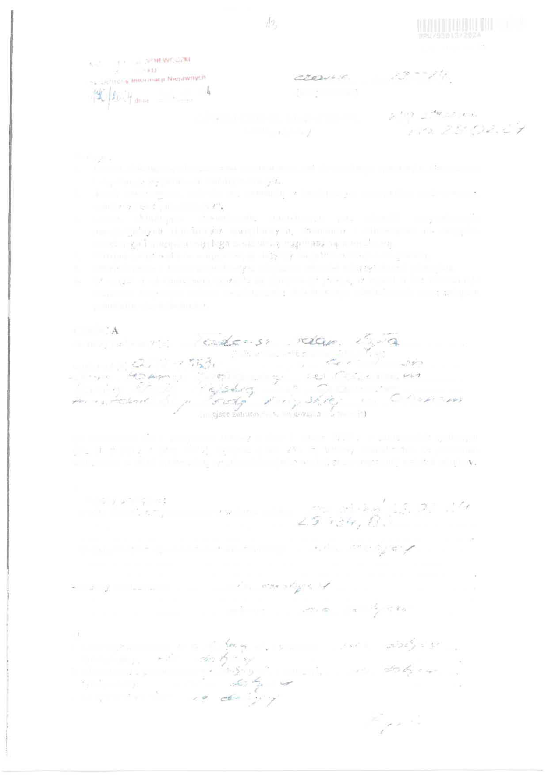


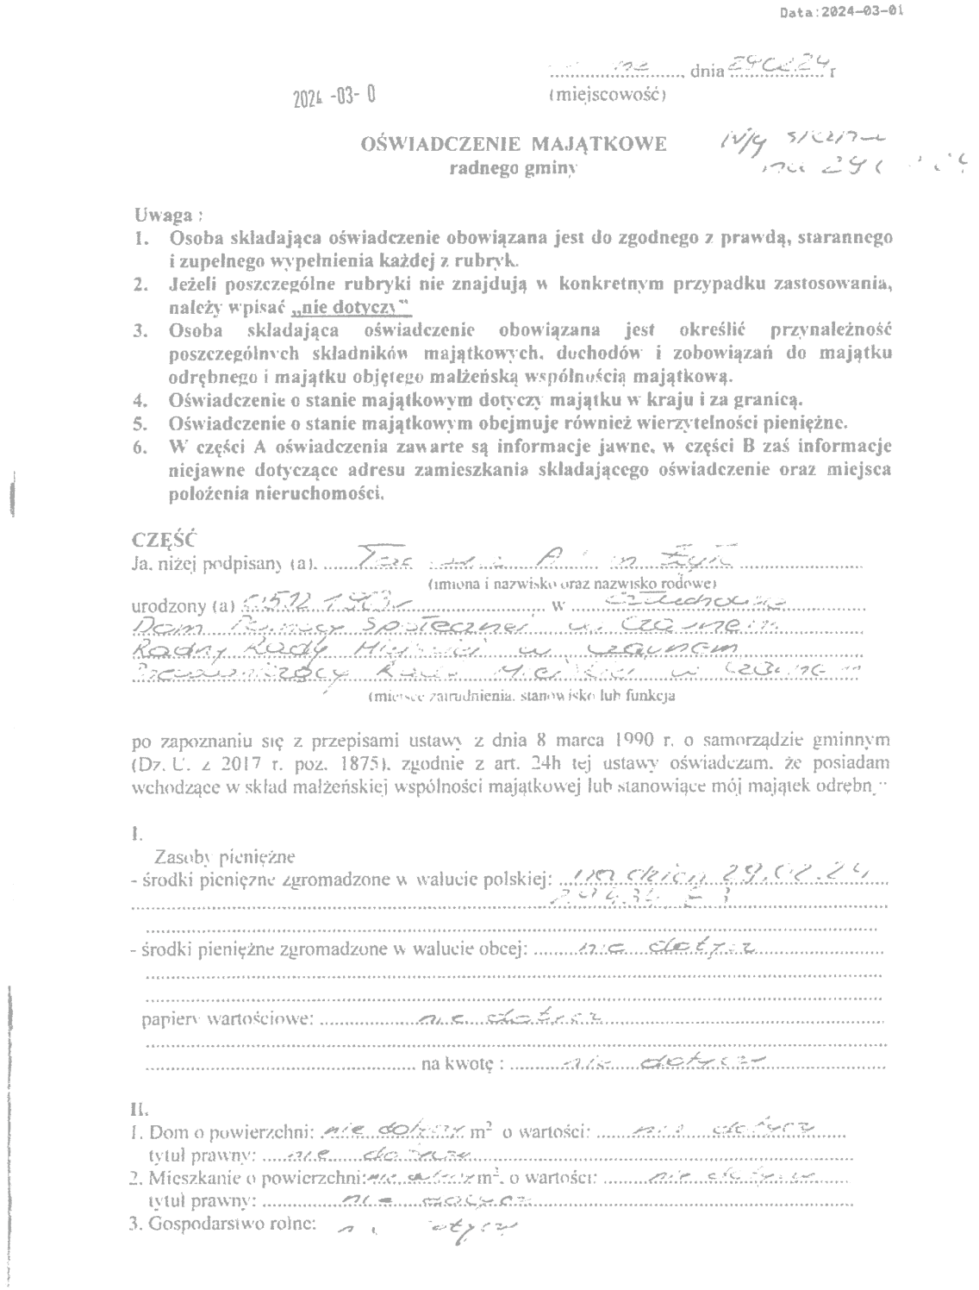

PDF-XChange Editor
DEMO
PDF-XChange Editor
DEMO
PDF-XChange Editor
DEMO
PDF-XChange Editor
DEMO
PDF-XChange Editor
DEMO
PDF-XChange Editor
DEMO
PDF-XChange Editor
DEMO
PDF-XChange Editor
DEMO
PDF-XChange Editor
DEMO
PDF-XChange Editor
DEMO
PDF-XChange Editor
DEMO
PDF-XChange Editor
DEMO
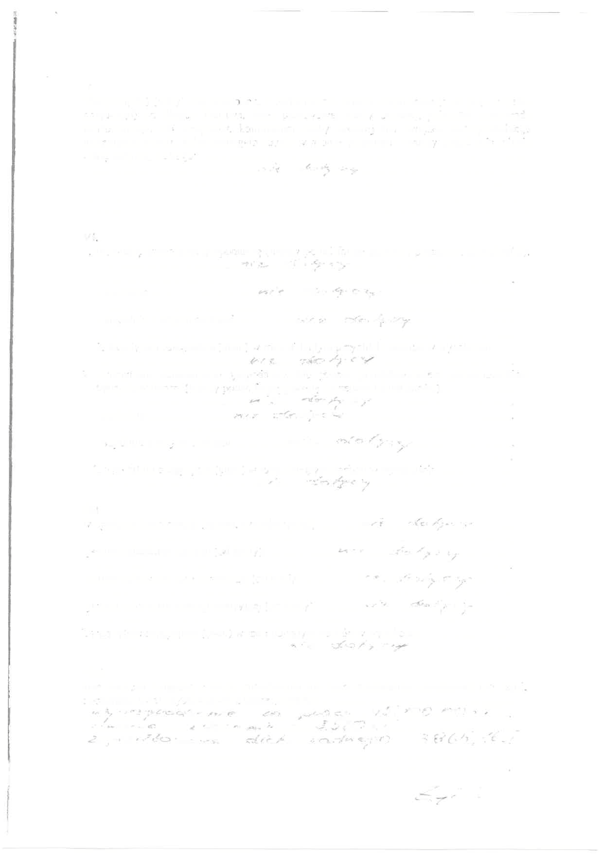
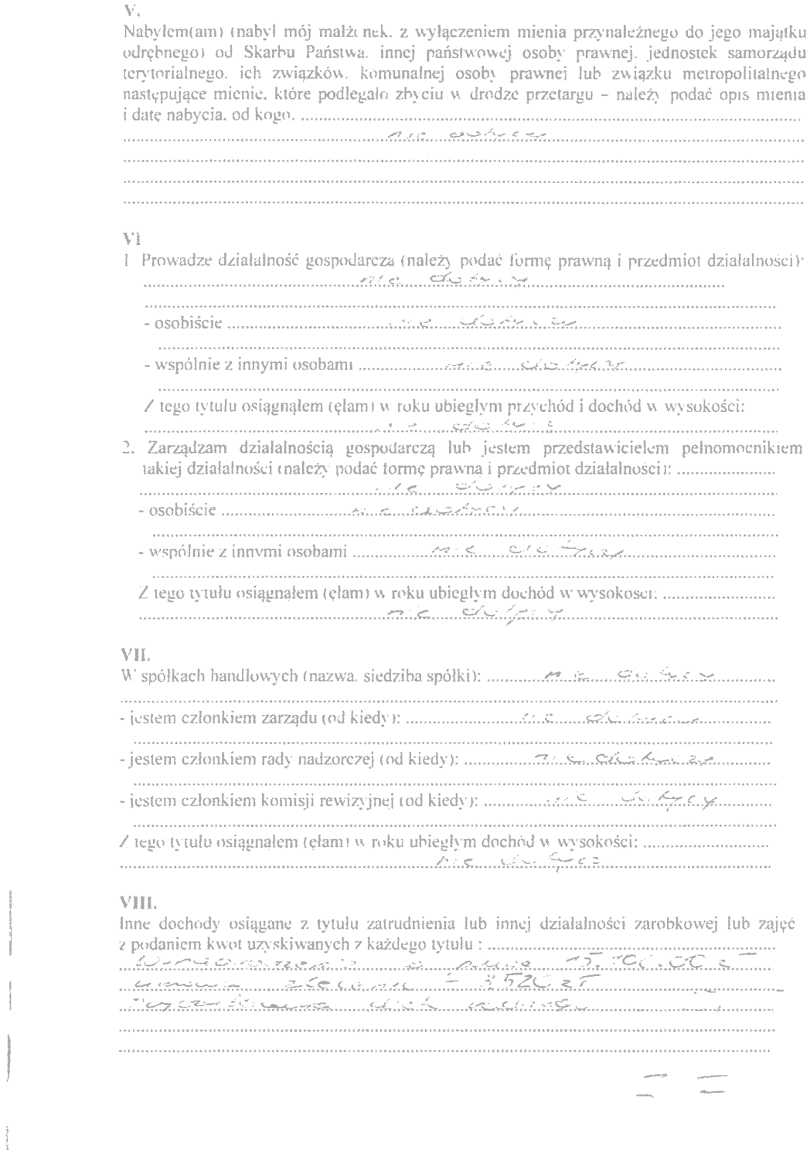


PDF-XChange Editor
DEMO
PDF-XChange Editor
DEMO
PDF-XChange Editor
DEMO
PDF-XChange Editor
DEMO
PDF-XChange Editor
DEMO
PDF-XChange Editor
DEMO
PDF-XChange Editor
DEMO
PDF-XChange Editor
DEMO
PDF-XChange Editor
DEMO
PDF-XChange Editor
DEMO
PDF-XChange Editor
DEMO
PDF-XChange Editor
DEMO

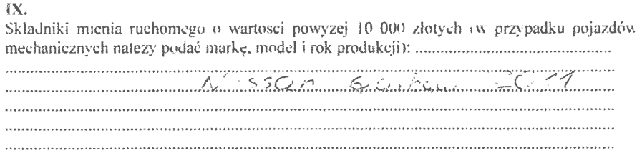


PDF-XChange Editor
DEMO
PDF-XChange Editor
DEMO
PDF-XChange Editor
DEMO
PDF-XChange Editor
DEMO
PDF-XChange Editor
DEMO
PDF-XChange Editor
DEMO
PDF-XChange Editor
DEMO
PDF-XChange Editor
DEMO
PDF-XChange Editor
DEMO
PDF-XChange Editor
DEMO
PDF-XChange Editor
DEMO
PDF-XChange Editor
DEMO



PDF-XChange Editor
DEMO
PDF-XChange Editor
DEMO
PDF-XChange Editor
DEMO
PDF-XChange Editor
DEMO
PDF-XChange Editor
DEMO
PDF-XChange Editor
DEMO
PDF-XChange Editor
DEMO
PDF-XChange Editor
DEMO
PDF-XChange Editor
DEMO
PDF-XChange Editor
DEMO
PDF-XChange Editor
DEMO
PDF-XChange Editor
DEMO

PDF-XChange Editor
DEMO
PDF-XChange Editor
DEMO
PDF-XChange Editor
DEMO
PDF-XChange Editor
DEMO
PDF-XChange Editor
DEMO
PDF-XChange Editor
DEMO
PDF-XChange Editor
DEMO
PDF-XChange Editor
DEMO
PDF-XChange Editor
DEMO
PDF-XChange Editor
DEMO
PDF-XChange Editor
DEMO
PDF-XChange Editor
DEMO

